**Machine Learning Engineer Nanodegree**

**Capstone Report (LANL Earthquake Prediction from Kaggle Competition)**

Tobias Steidle

([tobias.steidle@softwaredev.de](mailto:tobias.steidle@softwaredev.de))

June 24th, 2019

**Report**

# I. Definition

### Projekt Overview

This project is about predicting when an earthquake will occur. Based on seismic data and using a machine learning method, it will be determined when the earthquake will occur and how much time will elapse before the earthquake occurs.

The project is designed as a Kaggle Challenge. This means that the training and test data will be made available on the Kaggle platform. And it is a competition to achieve the lowest "Mean Absolute Error" on the test data. If the problem is solved, the trained model can be scaled to real data. This gives researchers the potential to improve predictions of earthquake hazards and save lives and billions of dollars in infrastructure.

### Problem Statement

The goal in this project is to achieve the lowest possible MAE (Mean Absolute Error) on the test data set. A MAE as small as possible in this case means that the predicted time period, until the earthquake occurs, is close to the real-time periods on which the test data is based.

The following steps are necessary to solve this problem:  
1. download the data from Kaggle  
2. visualizing the data for a better understanding  
3. preprocessing of the data  
4. training a suitable regressor  
5. writing the submission file for the Kaggle Competition

The submission file is then transmitted to Kaggle to set the score.

### Metrics

The used metric is the Mean Absolute Error. The Mean Absolute Error measures the average magnitude of the errors in a set of predictions, without considering their direction. It’s the average over the test sample of the absolute differences between prediction and actual observation where all individual differences have equal weight.

$$MAE= \frac{1}{n}\sum_{j=1}^{n}{\left|y_{j}-{\hat{y}}_{j}\right|}$$

$n$ = Number of predicted values $y_{j}$ 
 = real value ${\hat{y}}_{j}$ 
 = predicted value

For each record oft he test dataset the prediction error is calculated. Convert each error to a positive figure by taking the absolute value for each error. Finally, calculate the mean value for all recorded absolute errors.

Da es sich hier um eine Kaggle Competition handelt ist die Metrik in diesem Fall vorgegeben.

# II. Analysis

### Data Exploration

#### The data sets are freely available for download on the Kaggle competition website.

#### The data consists of a train.csv file containing a single, continuous training segment of experimental data. And test data in the test.zip file.

#### Input Data fields

* acoustic_data - the seismic signal [int16]
* time_to_failure - the time (in seconds) until the next laboratory earthquake [float64]
* Total rows in this train dataset: 629145480.

#### Test data set

* test.zip containing many small segments of test data.
* test dataset that is split into 2624 files , each one containing 150,000 acoustic_data points

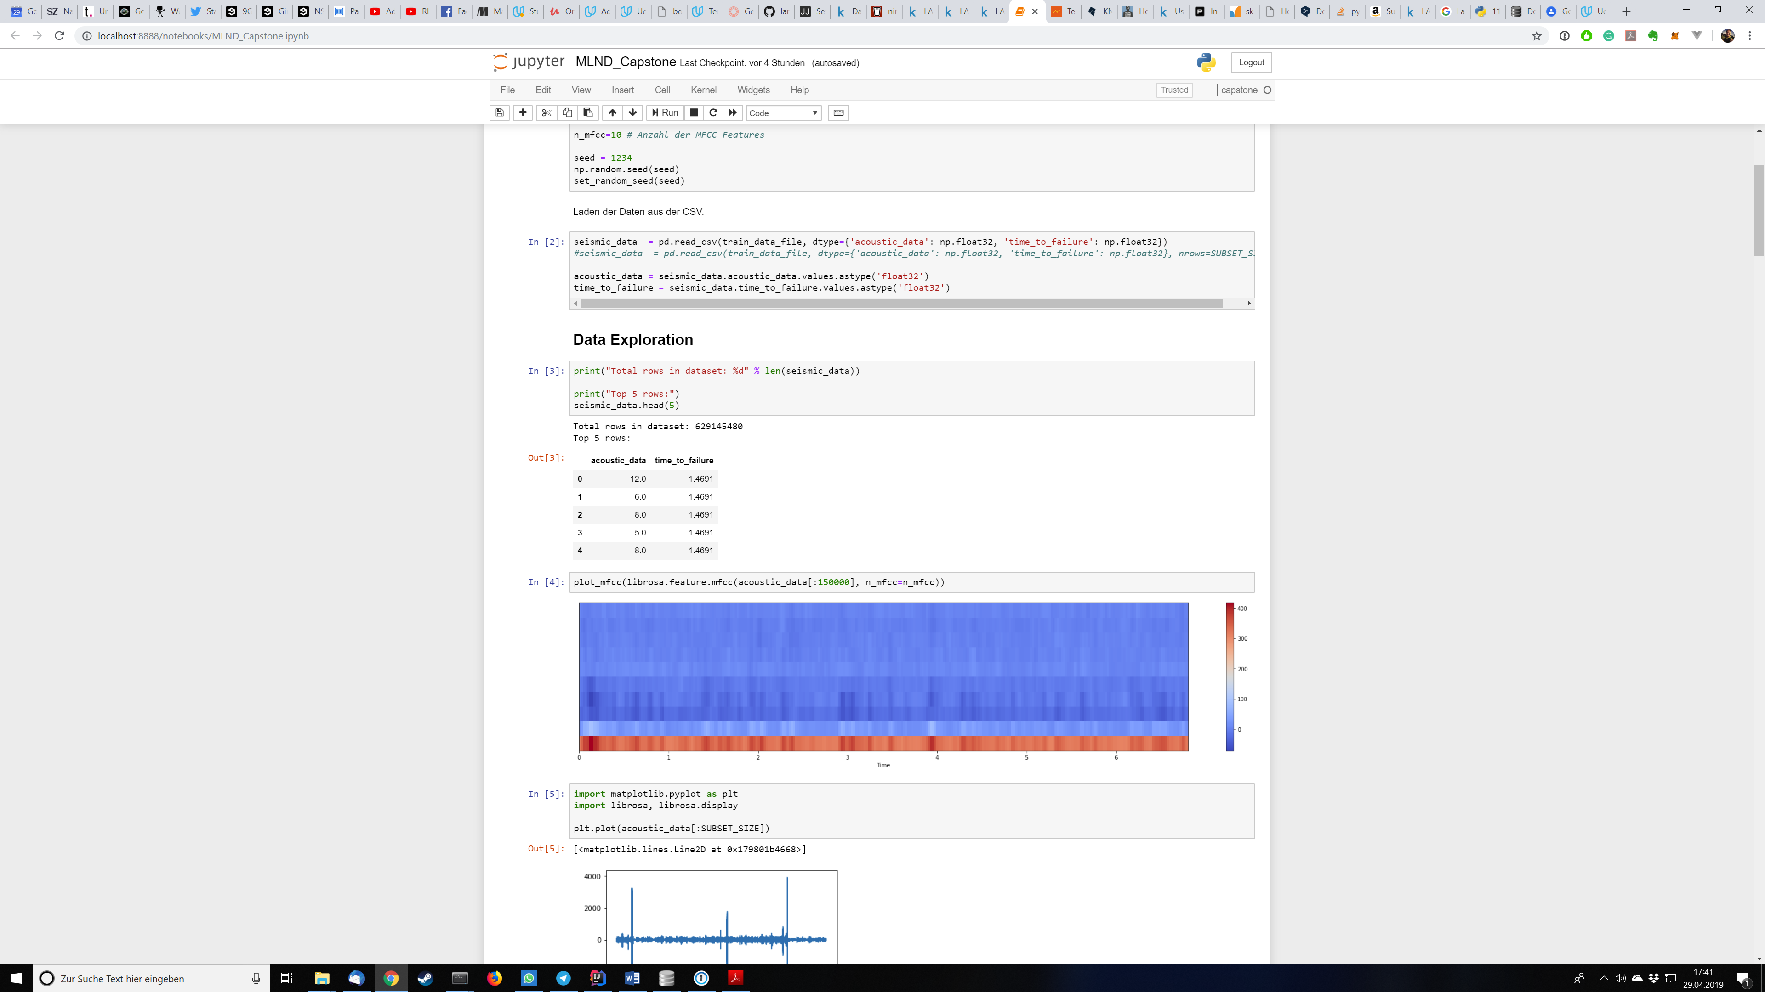  
Auszug aus den Trainingsdaten

What is not apparent at a glance on the data extract is that the "time_to_failure" in these 5 lines looks identical, but it is not. There are several digits after the comma in the real dataset. The "time_to_failure" is descending until the earthquake occurs. After the earthquake, the "time_to_failure" is increased again. This means that the training data contains several segments (start of measurement until the earthquake occurs).

### Exploratory Visualization

The data consists of the "acoustic_data" points and the "time_to_failure".

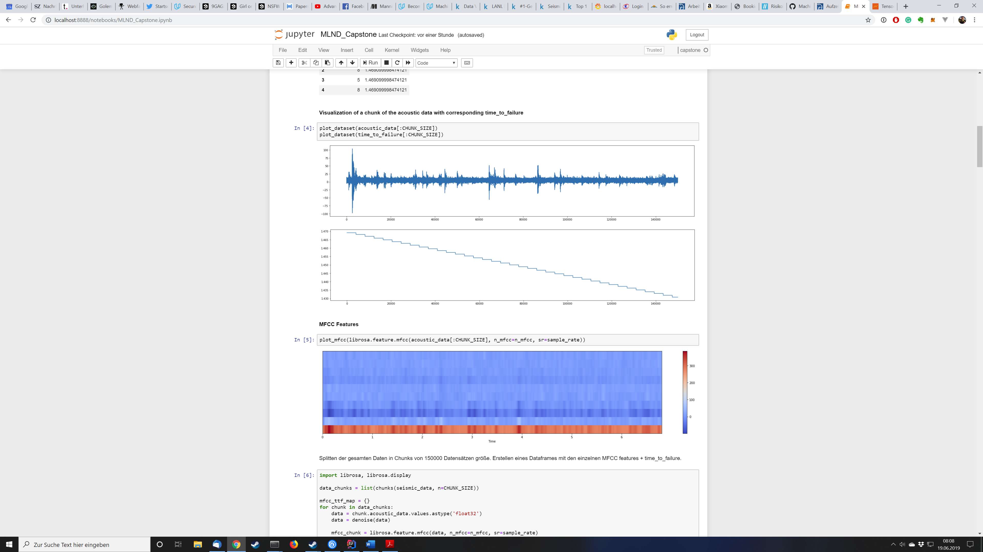  
Fig. 1

Fig. 1 shows the acoustic data. In this plot, you can see the height of the amplitude on the y-axis or in other words the strength of the signal. The higher the amplitude, the stronger the signal. The x-axis shows the time course.

  
Fig. 2

Fig. 2 shows the value "time_to_failure". The time until the event is shown on the y-axis. On the x-axis, as in Fig. 1, the time course. The further the time progresses, the shorter the time until the event occurs.

The plots show how the acoustic signal in Fig. 1 behaves until the event occurs.

### Alorithms and Techniques

To solve this problem I plan to use a Recurrent Neural Network (RNN). An RNN is especially well suited to perform e.g. a speech processing by machine. The available data is an acoustic signal. So it is obvious that methods which are used e.g. for the processing of natural speech can also help to solve this problem.

Depending on the neural network there are various parameters that can be adapted or optimized:

* Batch Size
* Epochs
* Train/test split of data
* Number and type of individual layers (LSTM, Dropout, Dense, ...)
* Optimizer (incl. associated parameters)
* learning rate

How the data is prepared is dealt with separately in the section Data Preprocessing.

### Benchmark

The benchmark for the final RNN is a Mean Absolute Error achieved by KNeighborsRegressor. The KNeighborsRegressor is trained like the final model with the preprocessed data. The achieved Mean Absolute Error can be compared as a reference value with the MAE of the final model. This allows you to determine whether the final model shows an improvement over a non-optimized model.

The mean absolute error for the benchmark is approx. **2.16**

# III. Methodology

### Data Preprocessing

To process the acoustic signals, the signal is not used directly but an MFCC (Mel Frequency Cepstral Coefficients) is applied. The MFCC leads to a compact representation of the frequency spectrum. For my final version, I have chosen a number of 10 coefficients. The sample rate was set to 44100. Here is a visualization of the MFCC.

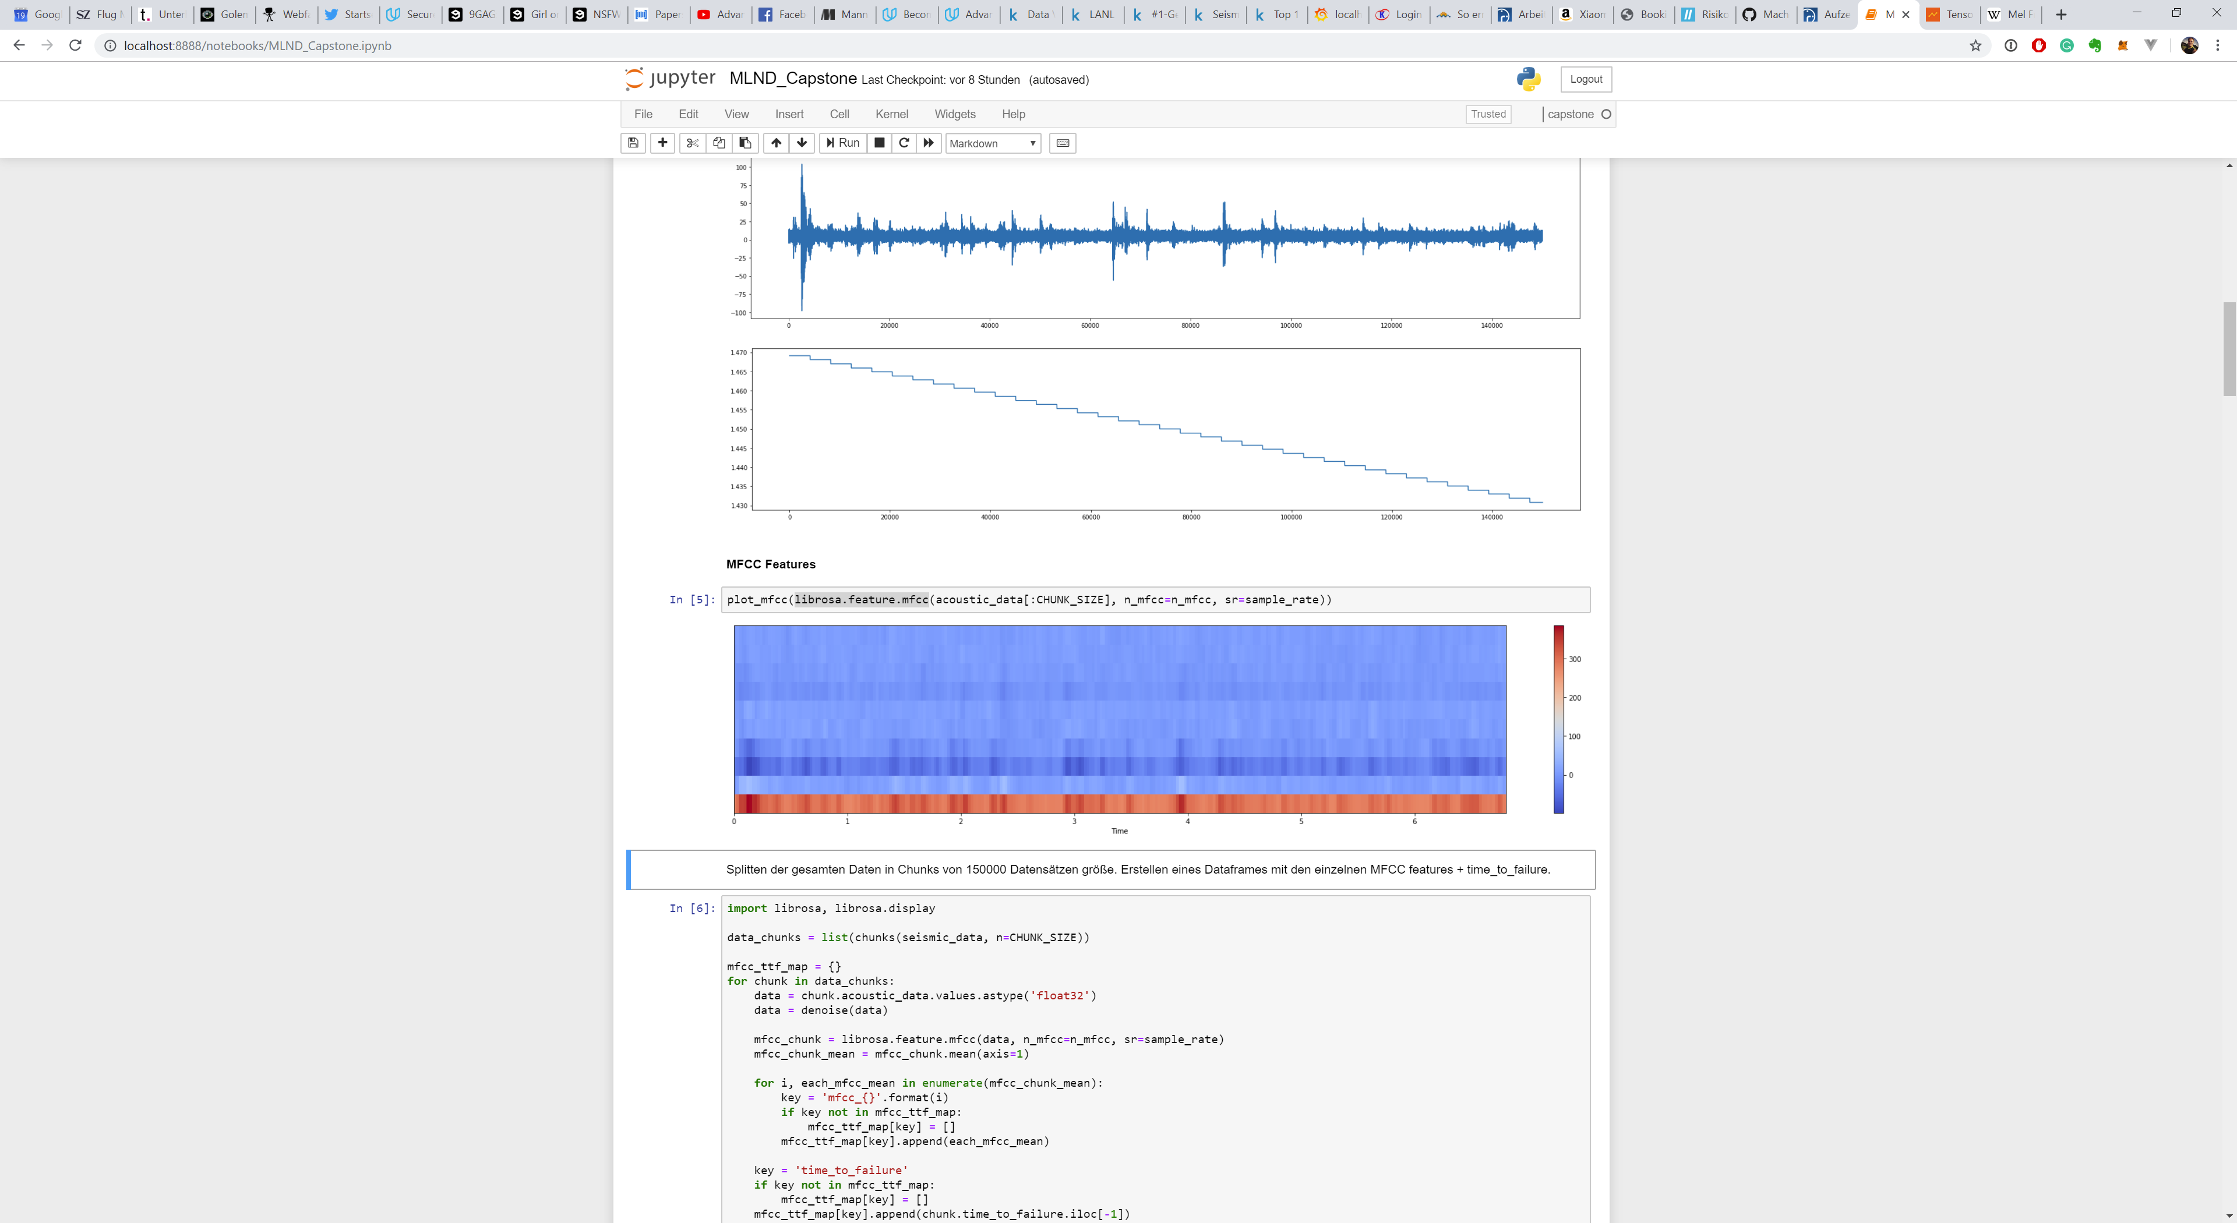  
Fig. 3

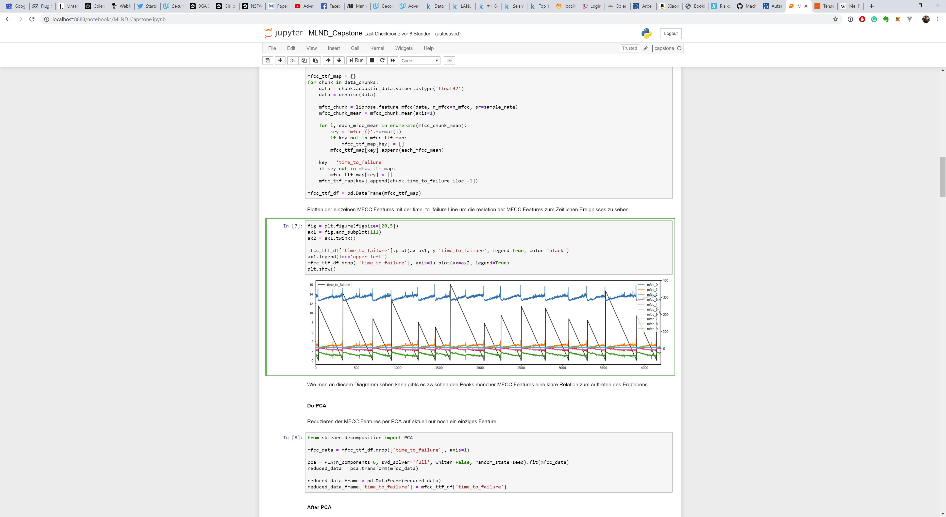  
Fig. 4

Fig. 3 shows the visualization of the frequency spectrum. Fig. 4 shows the individual MFCC features in connection with "time_to_failure".

As can be seen on this plot, the curves of individual features are relatively identical. For example, there is a great similarity between "mfcc_2" and "mfcc_3". Therefore, I decided to reduce the MFCC features additionally via a Principal Component Analysis (PCA) from 10 to 6 features. This leaves only the most relevant features and the training time is reduced.

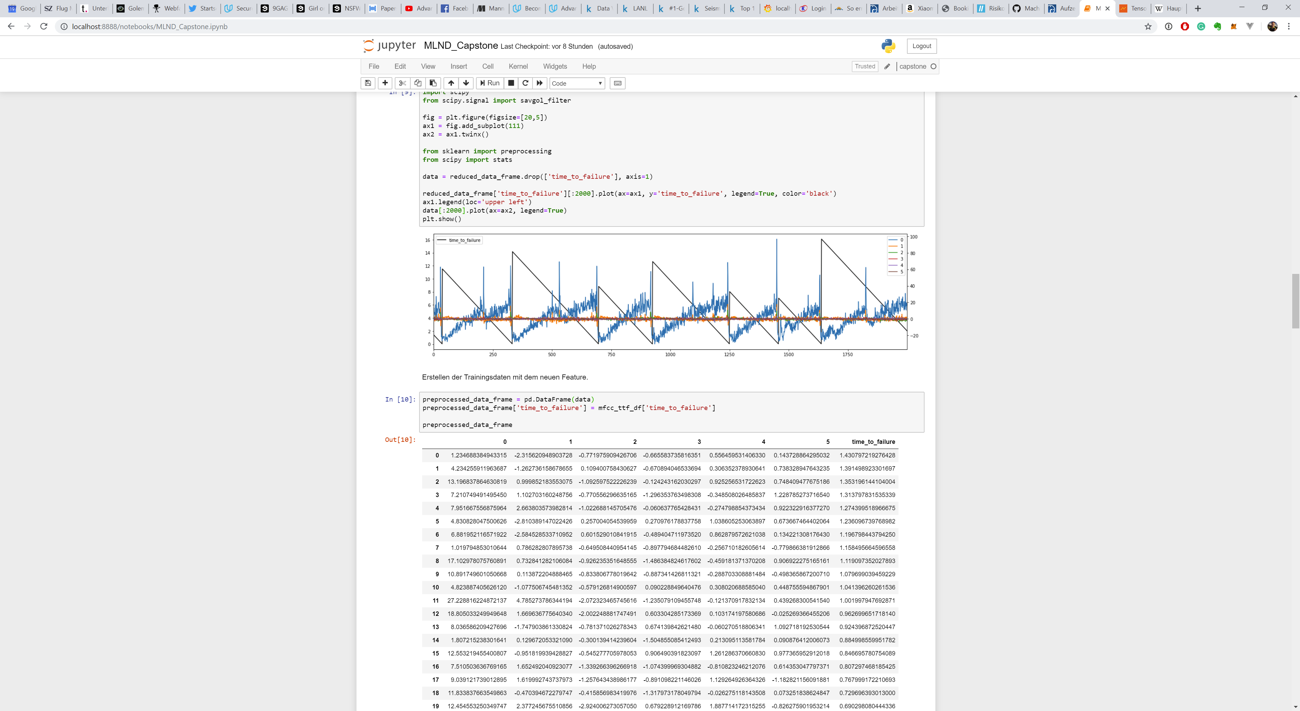  
Fig. 5

Fig. 5 shows the visualization with the remaining 6 features used for the training.

### Implementation

For the implementation 2 approaches were tried. The first step was to solve the problem with Scikit and an XGBRegressor. The final model was an RNN.

After pre-processing the data via MFCC and PCA, the data was split into training and test data:  
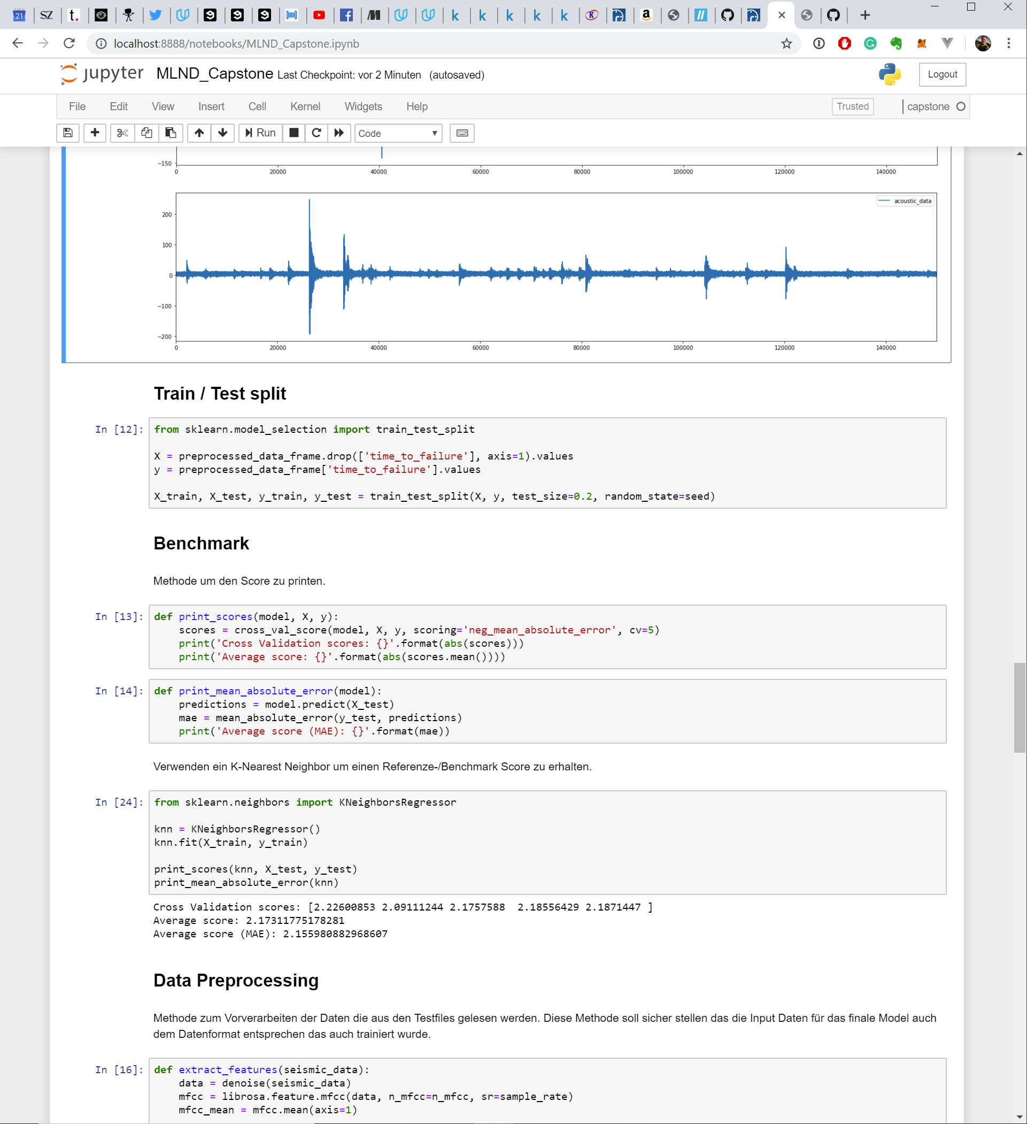

After splitting the data, the implementation of the XGBRegressor begins.

#### XGBRegressor

The implementation of the XGBRegressor is as follows:  
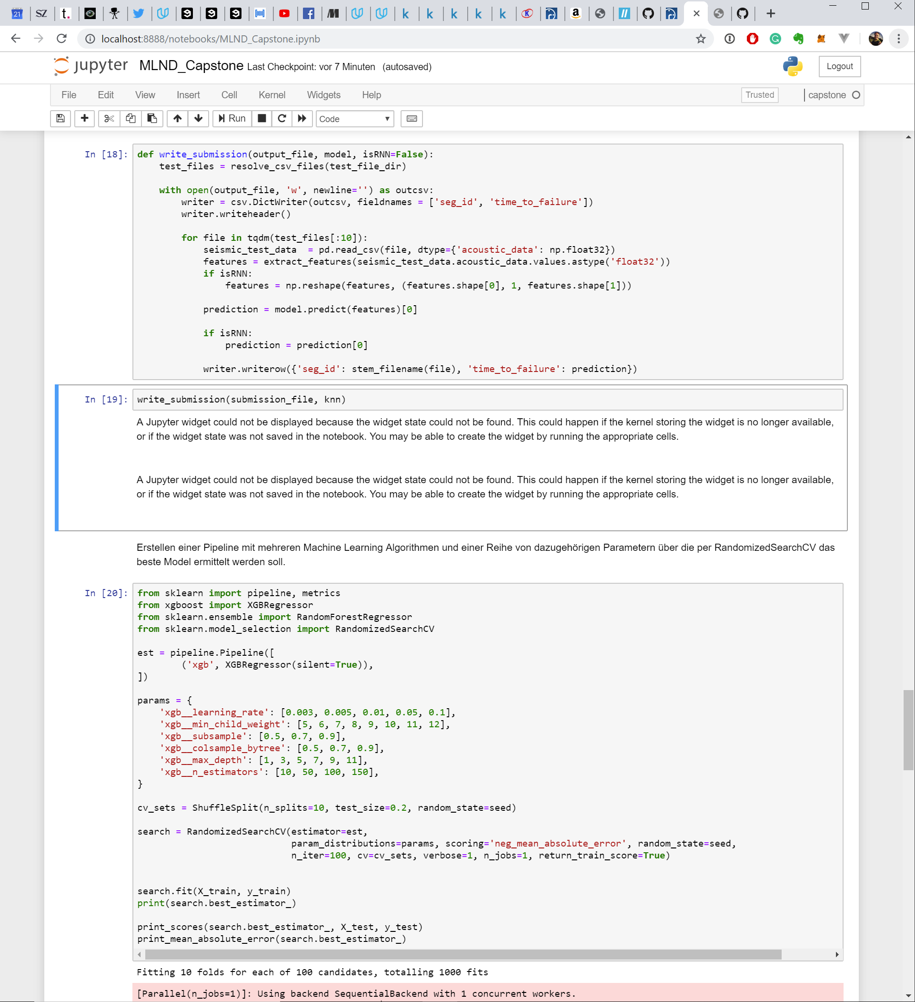

A large part of the implementation here is the use of RandomizedSearchCV. RandomizedSearch was chosen here because it requires less computing power than GridSearchCV and the best hyperparameters can be determined more quickly. It would be possible to combine the methods and after a run of the RandomizedSearchCV with the most important parameters to perform a GridSearchCV afterward. However, it has been shown that RNN delivers better results right away, so the XGBRegressor for the final version was discarded. For comparison, however, this method was retained in the Jupyter notebook.

#### Recurrent Neural Network

The implementation of the RNN is as follows:  
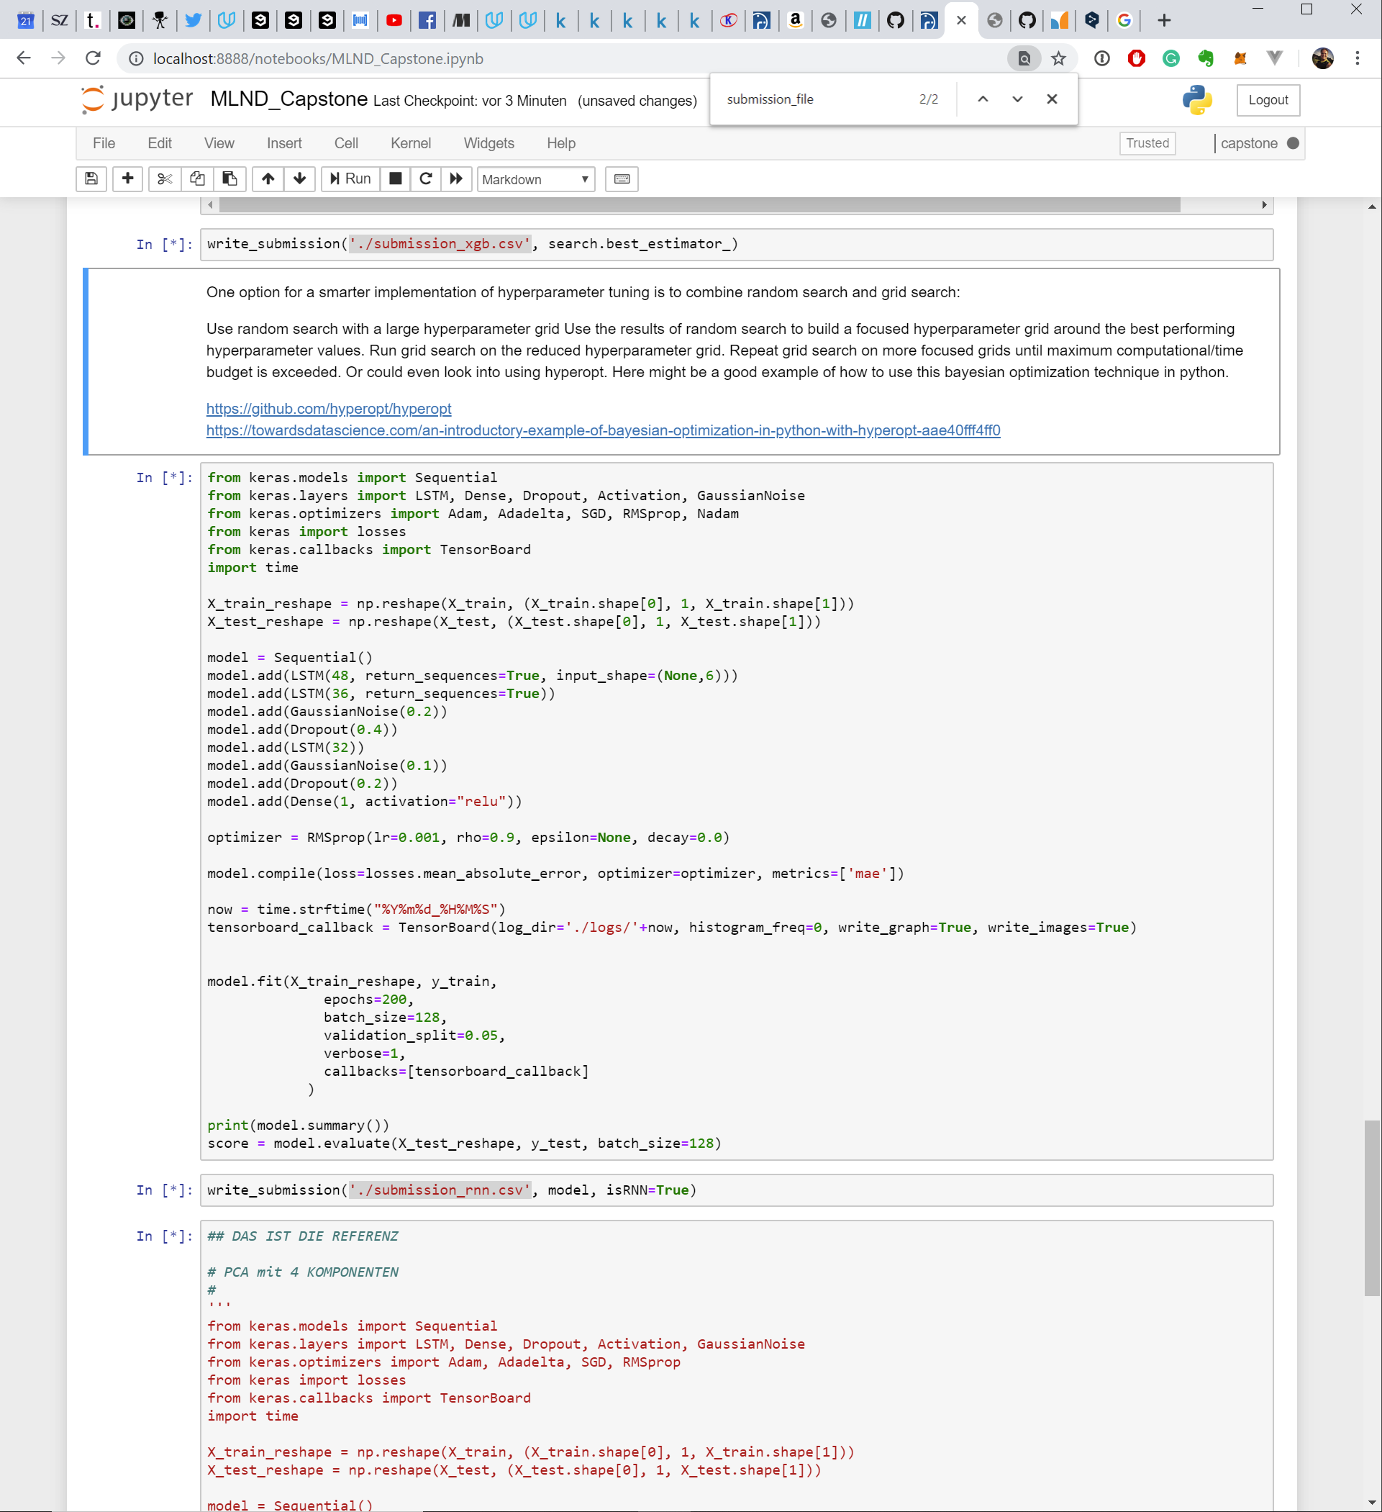

First of all, the training and test data had to be reshaped so that it could be processed by the LSTM. Then the model was built with different layers, the optimizer was defined and the model was compiled. Tensorboard was used to visualize the course of the training.

### Refinement

During the training of the model, it was shown that it is not necessary to train more than 200 episodes. For better understanding, here is the course of the Mean Absolute Error during training.

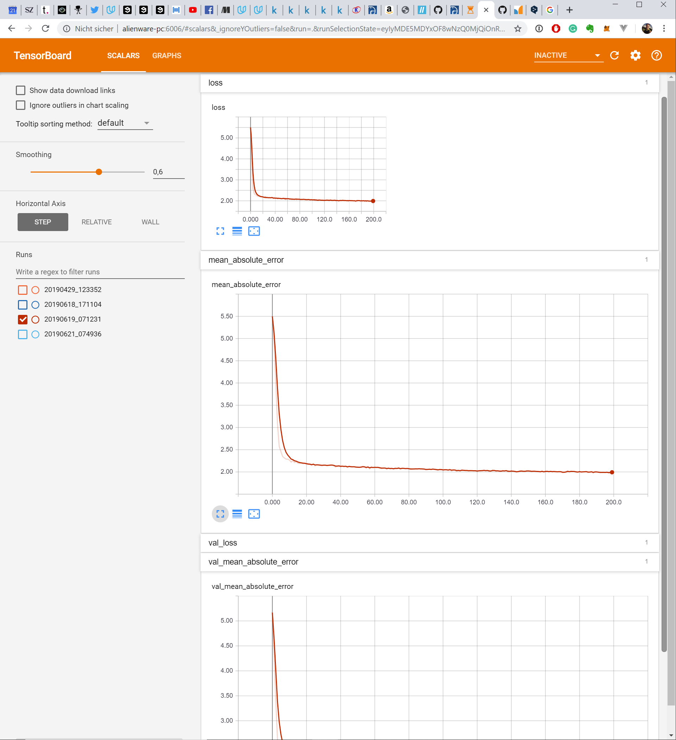  
Fig. 6

Depending on the parameters used, the curve is different, but it has been shown that 200 episodes are sufficient at this point.

Due to the few episodes and the features reduced to 6 by PCA, the training time was relatively short. Thus it was possible to tune the architecture as well as the individual parameters manually.

The first versions showed that a larger model with many trainable parameters is counterproductive in this case. The MAE either stagnated at a relatively high value or the MAE increased again after a short valley. Overfitting also seemed to be a problem. It was therefore decided to use a model with relatively few trainable parameters.

# IV. Results

### Model Evaluation and Validation

The final model is structured as follows:  
_________________________________________________________________

Layer (type) Output Shape Param #

=================================================================

lstm_1 (LSTM) (None, None, 48) 10560

_________________________________________________________________

lstm_2 (LSTM) (None, None, 36) 12240

_________________________________________________________________

gaussian_noise_1 (GaussianNo (None, None, 36) 0

_________________________________________________________________

dropout_1 (Dropout) (None, None, 36) 0

_________________________________________________________________

lstm_3 (LSTM) (None, 32) 8832

_________________________________________________________________

gaussian_noise_2 (GaussianNo (None, 32) 0

_________________________________________________________________

dropout_2 (Dropout) (None, 32) 0

_________________________________________________________________

dense_1 (Dense) (None, 1) 33

=================================================================

Total params: 31,665

Trainable params: 31,665

Non-trainable params: 0

I used 3 Long short-term memory (LSTM) layers for the final implementation. 2 right at the beginning and an additional one in the further course. To avoid overfitting I added 2 Gaussian Noise layers and dropouts. The model is completed by a dense layer that provides a final "time_to_failure" prediction.

The model was tested with different layers as well as with different parameters. The final model provides a repeatable result of stable values.

### Justification

Since this project is a Kaggle Competition, in addition to the benchmark score, the achieved score for the Public Leaderboard can also be used for comparison.

In this section, I compare the values of the final model with those of the benchmark and the test solution with the XGB Regressor.

|  |  |
| --- | --- |
| **KNeighborsRegressor – Benchmark** | |
| *Mean Absolute Error* | *Kaggle Leaderboard* |
| 2.156 | 1.72618 |

|  |  |
| --- | --- |
| **XGB Regressor – interim solution** | |
| *Mean Absolute Error* | *Kaggle Leaderboard* |
| 2.026 | 1.49898 |

|  |  |
| --- | --- |
| **RNN Model – final solution** | |
| *Mean Absolute Error* | *Kaggle Leaderboard* |
| 1.992 | 1.36877 |

As can be seen from the MEA values, there were significant improvements in each version. In any case, with both the interim solution (XGB Regressor) and the final solution via RNN, the error was reduced compared to the benchmark. In the Kaggle Leaderboard the improvement of the score becomes even clearer.

I think it becomes clear that my final solution is able to solve the problem.

# V. Conclusion

### Free-Form Visualisation

  
Fig. 7

Fig. 8 shows the visualization of the features used for training before and after using the PCA. As can be seen on the plot above, some MFCC features are very similar in their course (not the values). It has been shown that a reduction of the features by the PCA produces a better result since otherwise a higher weighting has been created by equal running measurement curves and possibly more significant measurement curves have been superimposed.

### Reflection

The entire process can be summarized in a few steps:  
1. the problem is defined and a relevant public dataset is available  
2. the data were examined and analyzed  
3. the data has been preprocessed and features have been extracted  
4. a metric for evaluating the solution has been established  
5. a simple model was created as a benchmark  
6. a final model was defined and the parameters optimized  
7. the final solution has been evaluated

The most interesting as well as the most difficult aspect of this project was to identify the right features. I've never been involved with signal analysis before, so it was a challenge to find the right method to work within a final solution.

On the whole, the final solution meets my expectations. However, I wouldn't see it as a general approach to solving problems of this kind, because I lack experience in signal analysis and therefore don't have a complete toolbox of knowledge to solve problems of this kind.

### Improvement

I see great potential for improvement above all in the determination of the features. I had already made several attempts to suppress the original signal with various filters (e.g. Savgol Filter). But that didn't lead to a better result. Also adding new features by "classic" signal analysis would be an option. Both options require a deeper introduction to this topic.

For the implementation it would be cleaner if extracting the features for training and prediction would be done using the same method. Currently this is still a small source of error.